Group 46

S360233 Kabi Li

S360496 Chen Chen

PRT574   
SECURITY ASSESSMENT IN  
 SOFTWARE DEVELOPMENT

Assignment 2

Introduction:

We develop a user-friendly tool for scanning network ports to detect open, closed, and filtered ports. We use Nmap to scan ports, Tkinter to design UI and Reportlab to export report in PDF format. We followed YouTube tutorial to implement the port scanning functionality. This port scanner allows user to specify the IP address and port range to scan and to export scan results in PDF format. As demonstration, we scan all 65535 ports of IP address 192.168.0.184, and provide the scan result.

YouTube tutorial for Nmap port scanner: <https://www.youtube.com/watch?v=x4AE5yOF9pE&ab_channel=DavidBombal>

Files:

1. port_scanner_nmap.py
2. port_scan_report_2024-04-26 000620.pdf
3. Group 46_ assignment2 report.pdf

Features:

1. Easy for users to input parameters and interact with the application.
2. The port scanner can identify open, closed, and filtered ports.
3. Users can specify the IP address and port range to scan.
4. Users can export scan results in PDF format.

Instruction:

1. Installation:

* Install libraries python-nmap and reportlab

>> pip install python-nmap

>> pip install reportlab

1. Execution:
   * Run port_scanner_nmap.py

>> python port_scanner_nmap.py

* Input the IP address and port range, then click the “Start” to initiate the scan.
* After the scan is completed, export the scan results to a PDF report by clicking “Export to PDF”.
* Stop the scanning process at any stage by clicking “Stop”.

Demonstration:

1. Initial screen:

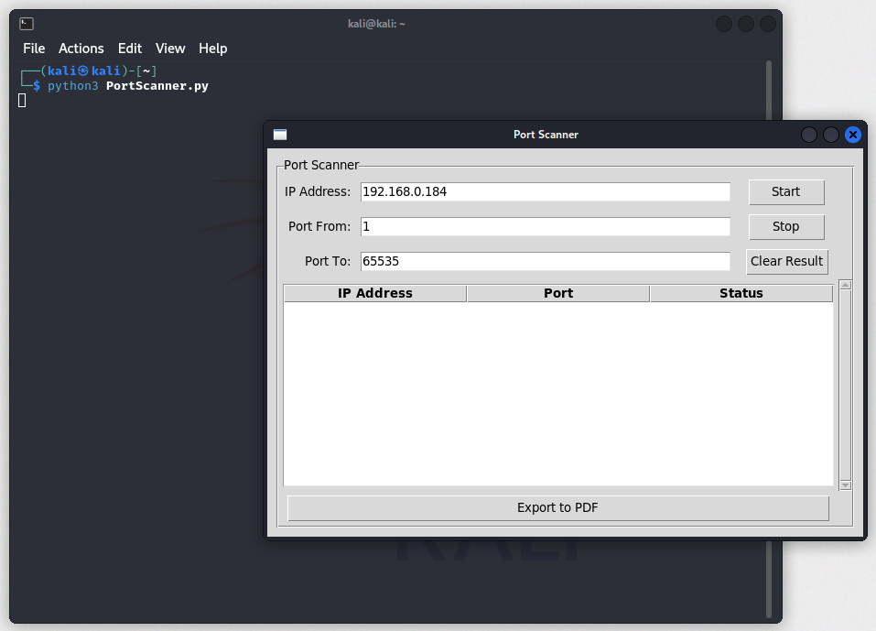

1. Input Parameters and Start Scan

*Message indicating scanning is in progress.

1. If the scan is completed, it will show completion message.

1. User can stop the scanning at any time.

1. User can export the scan port result in PDF format.

The filename is automatically defined based on the export datetime.

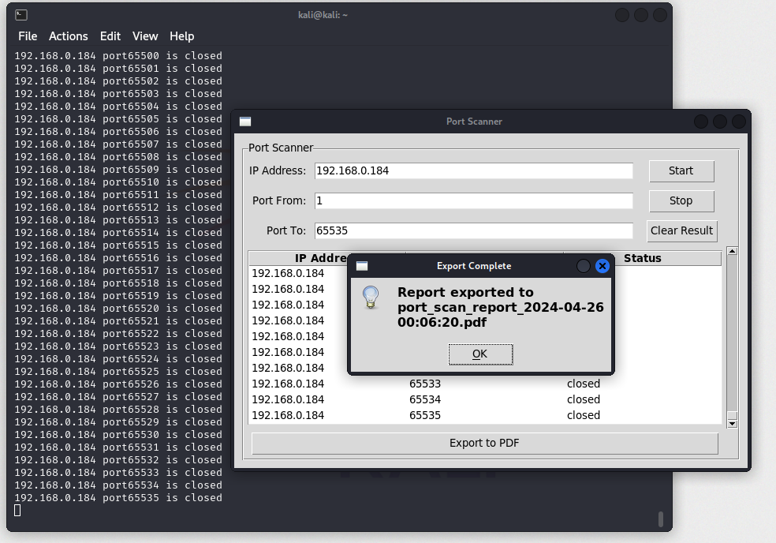

1. Scan Port Report includes:

* Report Summary: Provides the numbers of open, closed, and filtered ports.
* Open Ports List: Displays all the open ports.
* Scan Port Result: Shows the port results of all scanned ports.

In Scan Port Result, open port will be marked in yellow.

